Workshop, Acceptance Testing

ESPOL

Nicolas Joniaux

9/8/2023

<https://github.com/nicolasespol/taller_acceptance>

**Introduction:**

Acceptance testing is a crucial step in the software development process that involves verifying that a system meets the requirements and expectations of its users. This type of testing is typically performed by the end-users or clients of the system, and it focuses on ensuring that the system’s functionality, usability, and performance meet the specified criteria. Acceptance testing is an essential part of quality assurance, as it helps to identify any issues or defects that may impact the user experience before the system is released.

**Development:**

For this workshop, we were tasked with to do a ToListManager, add 1 more functionality and test it.

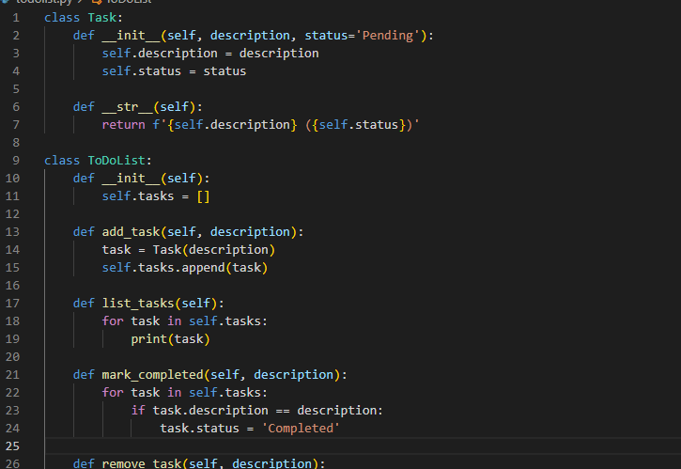

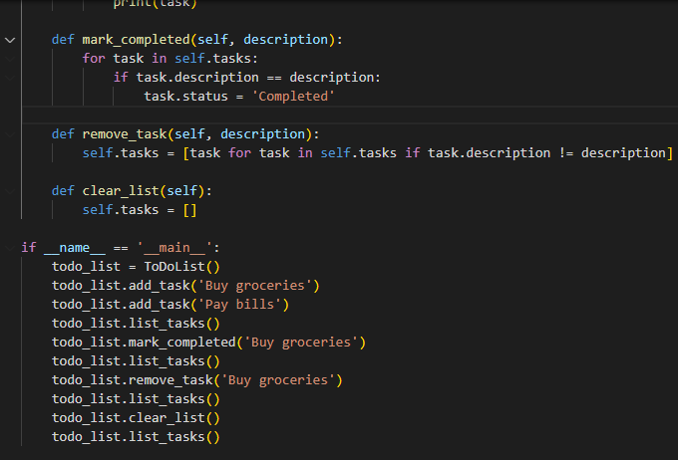

We have added the functionality of deleting a single task, in remove_task.

Now, for the testing, we define the 4 standard scenarios plus 1 additional scenario to test the new feature we added on top of the basic ones.

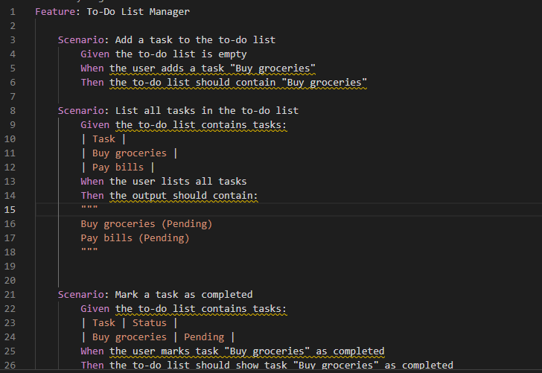

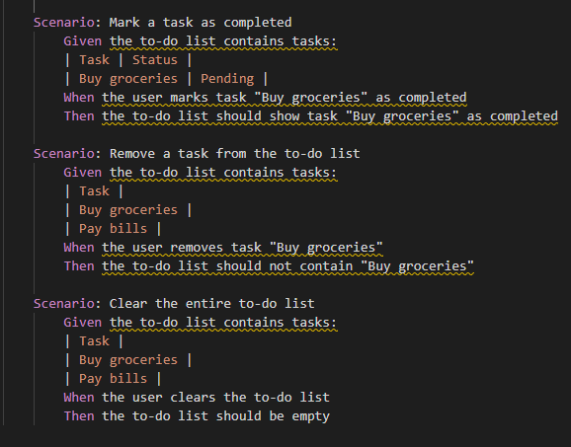

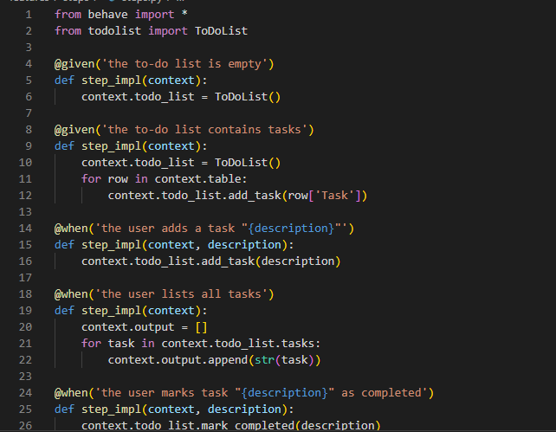

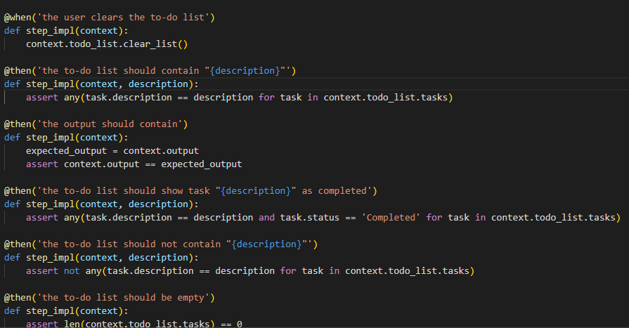

As we can see, we have defined all 5 cases and now we test.

In the first testing round, we encounter a mistake, which fails the list all tasks scenario:  
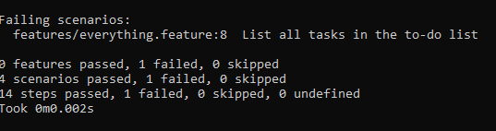

Now, since our program prints the status in the to dict, we must also print that in order to compare correctly. We fix that and run the tests again:

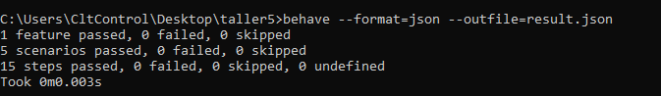

All 15 steps for all scenarios, and the 5 scenarios have been cleared succesfully.

**Conclusions:**

Acceptance testing is a vital part of the software development process that helps to ensure that a system meets the needs and expectations of its users. By performing acceptance testing, developers can identify and address any issues or defects that may impact the user experience before the system is released. This helps to improve the overall quality of the system and increase user satisfaction.

Recommendations:

* Involve end-users or clients in the acceptance testing process to ensure that their needs and expectations are met.
* Develop clear acceptance criteria to guide the testing process and ensure that all requirements are met.
* Use a structured approach to acceptance testing, such as creating test cases and documenting test results, to ensure thorough and consistent testing.
* Address any issues or defects identified during acceptance testing quickly to improve the quality of the system before release.

**References:**

None used.